Chapter 5, Solution 24

v₁ R_{f}

R₁ R₂

- v_{s} + -
+
+
R₄
R₃ v_{o}
v₂ -

We notice that v₁ = v₂. Applying KCL at node 1 gives

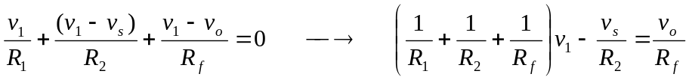 (1)
Applying KCL at node 2 gives

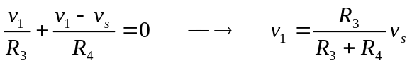 (2)
Substituting (2) into (1) yields

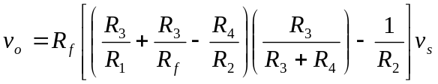
i.e.
